**Design of Algorithms: Assignment 2 Report**

**Part 4: Load Factor and Collisions**

A Jupyter Notebook was used to process the results, with Python code and the Pandas and Matplotlib libraries used to produce the visualizations and correlation values. The utility program cmdgen.c was used to generate the sequences of commands for each number of inserts, shown in **Figure 1**.

As shown in **Figure 1**, the number of inserts for each input to linear.c was increased by 200 for each test. As a demonstration of the relationship between inserts and collisions, I calculated their Pearson Correlation to be 0.953, showing a near linear relationship (**Figure 2**). This gives a reference point for the experiments on the relationship between the load factor, number of collisions and length of average probe sequence, since the number of inserts is the independent variable in this case.

The brackets either side of **Figure 1** demonstrate the periodic nature of load factor, collisions and length of average probe sequence values. The table is split by the total number of slots in the hash table, and shows that every time the hash table doubles in size, the number of collisions, load factor and length of average probe sequence decrease. We can therefore see how load factor follows the same periodic progression of values as number of collisions and length of average probe sequence.

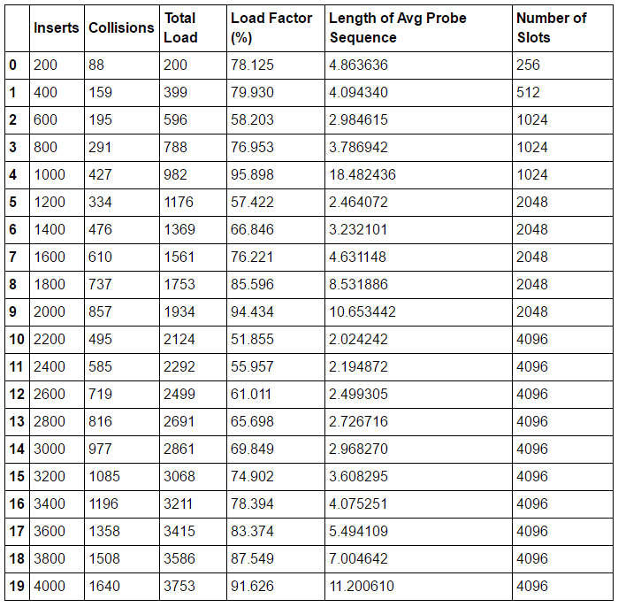

***Figure 1 – Table showing statistics of experiments with varying number of inserts***

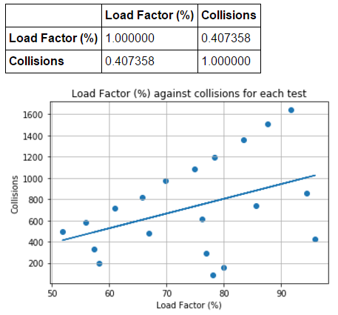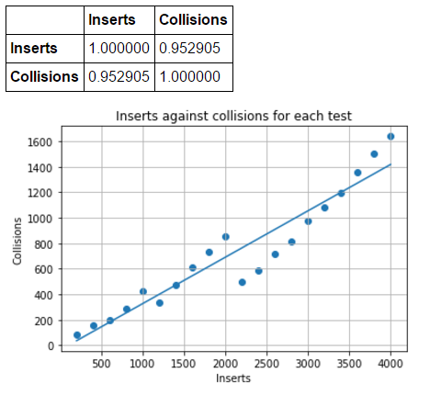

***Figure 2 – Inserts vs. Collisions Figure 3 – Load Factor vs. Collisions***

**Figure 3** shows the relationship between the hash table’s load factor and the number of collisions. The Pearson Correlation of 0.407 is indicative of a moderate correlation, which could be explained by the previous analysis showing the periodicity of the collected statistics. While the effect that doubling the hash table size has on load factor and collisions cannot be explicitly seen in **Figure 3**, the positive trends of three visible groups of values are indicative of how load factor interacts with collision number, with regards to the growing hash table size. Since the raw figures of collisions are relative to the number of inserts, which is not reflected in **Figure 3**, the three groups are visible.

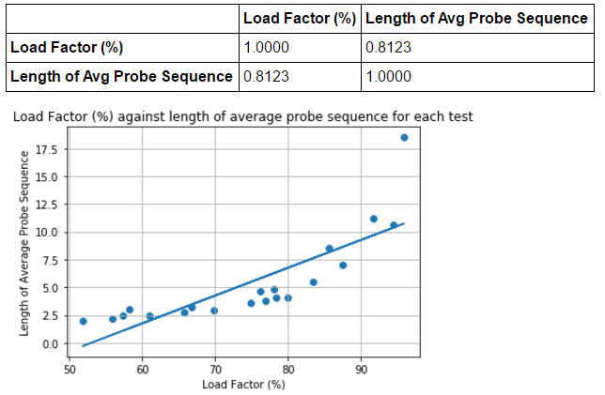The strong correlation between load factor and

length of average probe sequence is shown in

**Figure 4**, with a Pearson Correlation of 0.812.

While the line of best fit does not show this,

there appears to be an exponential increase

in length of average probe sequence as load

factor increases. When load factor approaches

100, the hash table doubles in size, resulting

in the length of average probe sequence

decreases, along with load factor.

***Figure 4 – Load Factor vs. Length of Avg Probe Sequence***

**Part 5: Keys Per Bucket**

The same method as in part 4 was used to produce the visualizations. To generate the input file, cmdgen.c was used to create an input file with 5,000 inserts and 5,000 lookups, and this file was run with xtndbln.c with input bucket sizes ranging from 4 (default bucket size) to 1004 buckets. The bucket sizes were incremented by 100 buckets each time.

By using bucket size as the independent variable in this case, I could experiment with the performance of my single key extendible hash table (via CPU Time) to show its relationship with the number of keys per bucket.

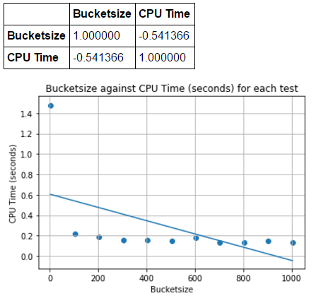The trend visible in **Figure 5** seems to

illustrate an exponential increase in

CPU Time as the bucket size decreases.

The massive drop in CPU Time from 4

to 104 buckets shows that a higher

bucket size results in a better

performance of the hash table, as CPU

Time decreases. However, it appears

that the decrease in CPU Time

approaches an asymptote, and the CPU

Time does not decrease significantly

beyond a bucket size of 204. In fact,

the CPU Time remains relatively

stagnant after that point, fluctuating

around 0.135 seconds.

The Pearson Correlation of -0.541

is indicative of a moderate to

strong negative correlation ***Figure 5 – Bucket size against Hash Table Performance (CPU Time)***

between CPU Time and the

keys per bucket. As a result of this experimentation, we can say that there definitely is a relationship between the number of keys per bucket (bucket size) and the performance of the hash table, however the benefit of increasing bucket size rapidly decreases after around 104 keys per bucket.